Eudey, Econ 302, January 2019
A one-period model of the representative firm Reference second half of Chapter 4
Reading
Things you can skip from this chapter:
For both editions 5 and 6
- An example: Consumption and Leisure are Perfect Complements
Profit Maximization
Firms are assumed to be profit-maximizers and the market structure is assumed to be perfectly competitive.
Profit is defined as
$$π=f\left(zK, zN\right)-wN$$
Where the term for profit is the same term used to define is non-labor income in the household maximization problem at the start of chapter 4. Profits are non-labor income.
The Aggregate Production Function: Constant Returns to Scale
The main assumption behind the Chapter 4 model of the firm is that the production function takes the following form:
$$Y=f\left(zK,zN\right)={(zK)}^{α}{(zN)}^{β}$$
Where z is defined as technological progress that improves the productivity of both K and N (and is therefore referred to as either “total” factor productivity or “multi” factor productivity).
Over long periods of time, and across many countries, economists have historically consistently found the following estimates from the aggregate data
α is estimated to be around 0.3
β is estimated to be around 0.7
and—at least using historical data—we cannot reject the hypothesis that
α + β = 1.

Which means that we can re-write the aggregate production function as
$y= {(zK)}^{α}{(zN)}^{β}$ = $z^{α}K^{α}z^{β}N^{β}$
$$y= z^{α+β}K^{α}N^{β}$$
y = $zK^{α}N^{β}$
y=zf(K,N)
Which means we can pull “total factor productivity” out in front of the rest of the production function. That means that changes in z affect GDP one for one whereas changes in either K or N affect GDP less than one for one; to get a 1 percentage point increase in GDP coming from an increasing in the capital stock, for example, the capital stock would have to increase by roughly 3 percentage points.
The “new economy” period of the 1990s was so unusual because the capital stock grew about 3 percent per year more than we normally observed in a healthy economy—this was the period in which we started using the internet, laying fiber optic cable, and using wireless communications (mobile phones etc) with an associated increase in our stock of those types of “new” capital goods.
This type of production function is referred to as Constant Returns to Scale because if population growth causes both K and N to increase by the same amount x% then GDP will also increase x% and output per person will be unchanged (no change in standard of living if capital growth just keeps up with population growth and there is no technological progress)
Proof:
Replace z with “3” in the previous math, so that both K and N are both 3 times larger. The sum of exponents on 3 is equal to one, so GDP is three times bigger (constant returns to scale). 3*GDP/(3*N) = GDP/N (no change in stuff per person).
This means that we can use the same production function to talk about big economies as to talk about small ones, which is convenient and something we will do.
Increasingly economists wonder if maybe the aggregate production function might not be best described this way—modern economies seem to have large fixed costs and to therefore have scale economies—but we’ll start with the standard approach and then use the Scientific Method to critique this model.

Solving for Labor Demand
Firms choose N that maximizes profits, taking w as “given” (constant).
$$π=zf\left(K,N\right)-wN$$

If you were to plot $zf\left(K,N\right)$ next to wN then the profit-maximizing level of N is the one that maximizes the vertical distance between the two curves:
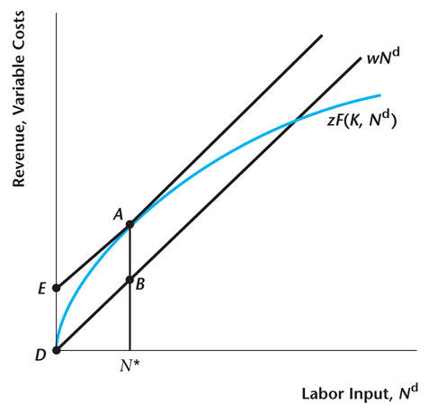
The wage bill has a constant slope because the firm is a price-taker (w is exogenous).
The production function has a positive but decreasing slope—it exhibits diminishing returns because the exponent on N in the production function is less than one (β<1 in y = $zK^{α}N^{β}$)
Proof:
The slope of the production function is the first derivative of y with respect to N:
y’ = β$zK^{α}N^{β-1}$ > 0
The change in the slope of the production function is the first derivative of the slope with respect to N:
y’’ = (β-1)β$zK^{α}N^{β-2}$ < 0
because (β-1) < 0
We know that (β-1) < 0 because we know that if the production function is Constant Returns to Scale then it must be that β < 1.

Shifts in labor demand
Changes in z have a one-for one shift in the production function; changes in K shift the production function less than one-for-one; changes in N are movements along the production function.
Increases in either z or K both lead to increases in labor demand.
Increases in the cost of labor (w) lead to decreases in labor demand.
Profit maximization and an exact economic forecast
The math in this case is much easier than it was for the household problem, and also much less ambiguous.
$$π=zf\left(K,N\right)-wN$$
Differentiating with respect to the choice variable N, and setting that first derivative equal to zero (marginal profits are zero), we have
$$π^{'}=MPN-w=0$$
Or
$$MPN=w$$
Where MPN is the marginal productivity of labor.
Under perfect competition workers get paid what they are worth (at the margin).
The math works out the same way as the graphs did:
Increases in either z or K both lead to increases in MPN as the first derivative of MPN with respect to either z or K is positive.
$$MPN>w$$

Holding the real wage constant, MPN must fall back down to its original level to be in equilibrium; this happens as labor input rises (first derivative of MPN with respect to N is negative)
- In summary: Nd rises as MPN goes up, which causes diminishing returns to N, which causes MPN to fall to its original level. Nd increases as in the graph with no change in real wage as in the graph
Increases in the cost of labor require matching increases in MPN (or firms regret hiring so many workers).
$$MPN<w$$

Firms cut back on labor demand and MPN rises (diminishing returns) until it reaches equilibrium once again.

